**COMPX202 Assignment8 Document**

**Students**

Name: ShengyangXu (X); ID: 31711055

Name: Dan Jin (J); ID:31711003

**Project Name**

Adventure Ball

**Software Methodology**

The iterative and incremental approach

**Backlogs**

|  |  |  |  |
| --- | --- | --- | --- |
| Task ID | Description | Author | ETA |
|  | App Icon Design | J | 2 hrs |
|  | GameUIdesign | J | 3hrs |
|  | Layout the welcome screen with XML | J | 1hrs |
|  | Define and code functions in welcome screen | X | 30 mins |
|  | Define functions in game screen | X | 30 mins |
|  | Define obstacles &target | J | 1 hrs |
|  | Define ball movement & score | J | 1 hrs |
|  | Visible hierarchy | X | 2hrs |
|  | Implement ball movement | X | 3hrs |
|  | Test ball movement | J | 2 hrs |
|  | Implement obstacle& reward effect | X | 7hrs |
|  | Test obstacle& reward effect | X | 3hrs |
|  | Implement score system | X | 3hrs |
|  | Test score system | J | 2 hrs |
|  | Define and code functions in ranking screen | J | 15 mins |
|  | Display pseudo data in ranking screen | X | 1 hrs |
|  | Use flow in home screen | J | 1 hrs |
|  | Use flow in game screen | X | 3 hrs |
|  | Use flow in score screen | X | 1 hrs |
|  | Test Use flow between screens | J | 2 hrs |
|  | Transfer data from home to game | X | 1 hrs |
|  | Transfer data from game to score | X | 2 hrs |
|  | Display Top 5 in score screen | X | 2 hrs |
|  | Test Top 5 in score screen | J | 1 hrs |
|  | Test the whole game | J | 5 hrs |

**Recordings**

Task1: AppIconDesign

**ETA**: 2 hrs, **Actual**: 1hrs

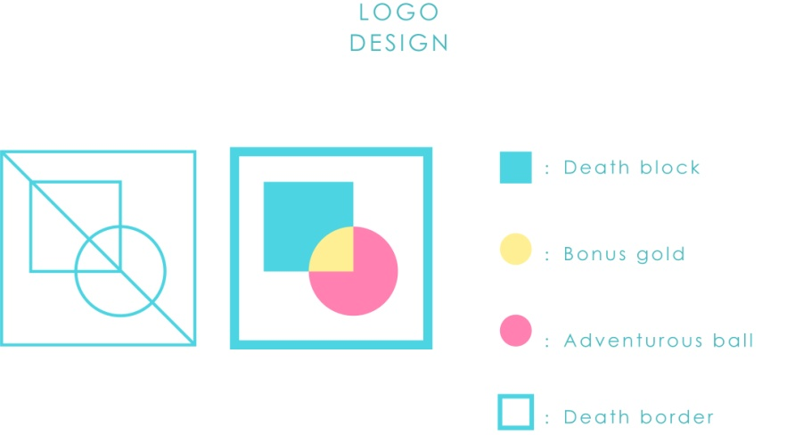

**Design Idea:** As a small leisure game, I want its logo to show the relaxed and happy atmosphere. Before designing the logo, our group has conceived the game's playing method and general content. I extracted the elements in the game and designed such a logo.

**Inspirations:** The design inspiration comes from the game itself. We try to make a small ball rolling by gravity. This small ball is in the game world where danger and opportunity coexist. On the left and right sides, it is the boundary between touch and death; in the middle, it is the death blue box and the bonus box. We use blue to represent the crisis. The edge line and the death box are defined as blue, and they are abstracted into four square rectangles. Use the yellow of gold coin to represent the bonus box and abstract it into a circle of gold coin.

The ball is naturally round, which needs to be eye-catching and represents the opposite "life" of death. I set it as a blue contrast - pink.

**Meanings:** The square and circle in the middle of the logo intersect, and the junction is yellow, which means that the pink ball shuttles through the blue death box, so it is possible to obtain "bonus gold coin" and "vitality". The shape of the bonus circle is the same as the small ball, indicating that only survival can continuously obtain scores. The blue box outside the logo also represents the death line on both sides of the game interface.

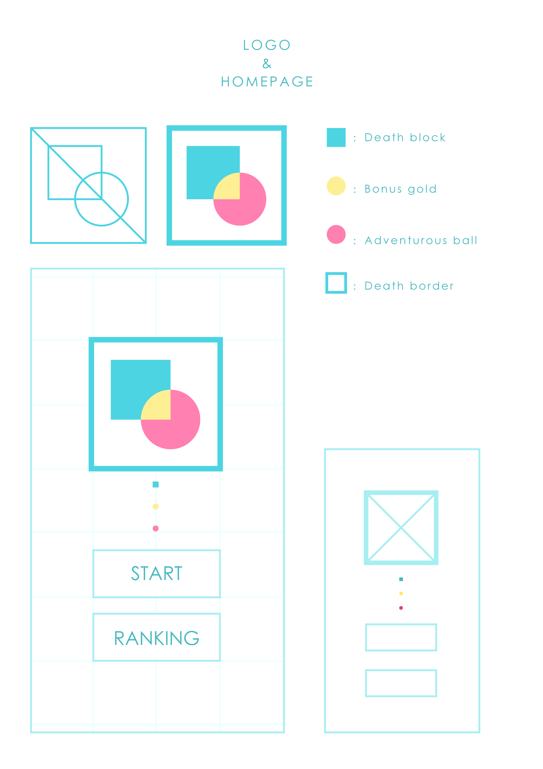

Task2: GameUIDesign

**ETA**: 3hrs, **Actual**: 3hrs

**1. Homepage:** The border of the two game buttons is selected with a color lower than the saturation of the logo border to make the text more prominent and clear. Choose

sans serif fonts to make the game more modern and concise.

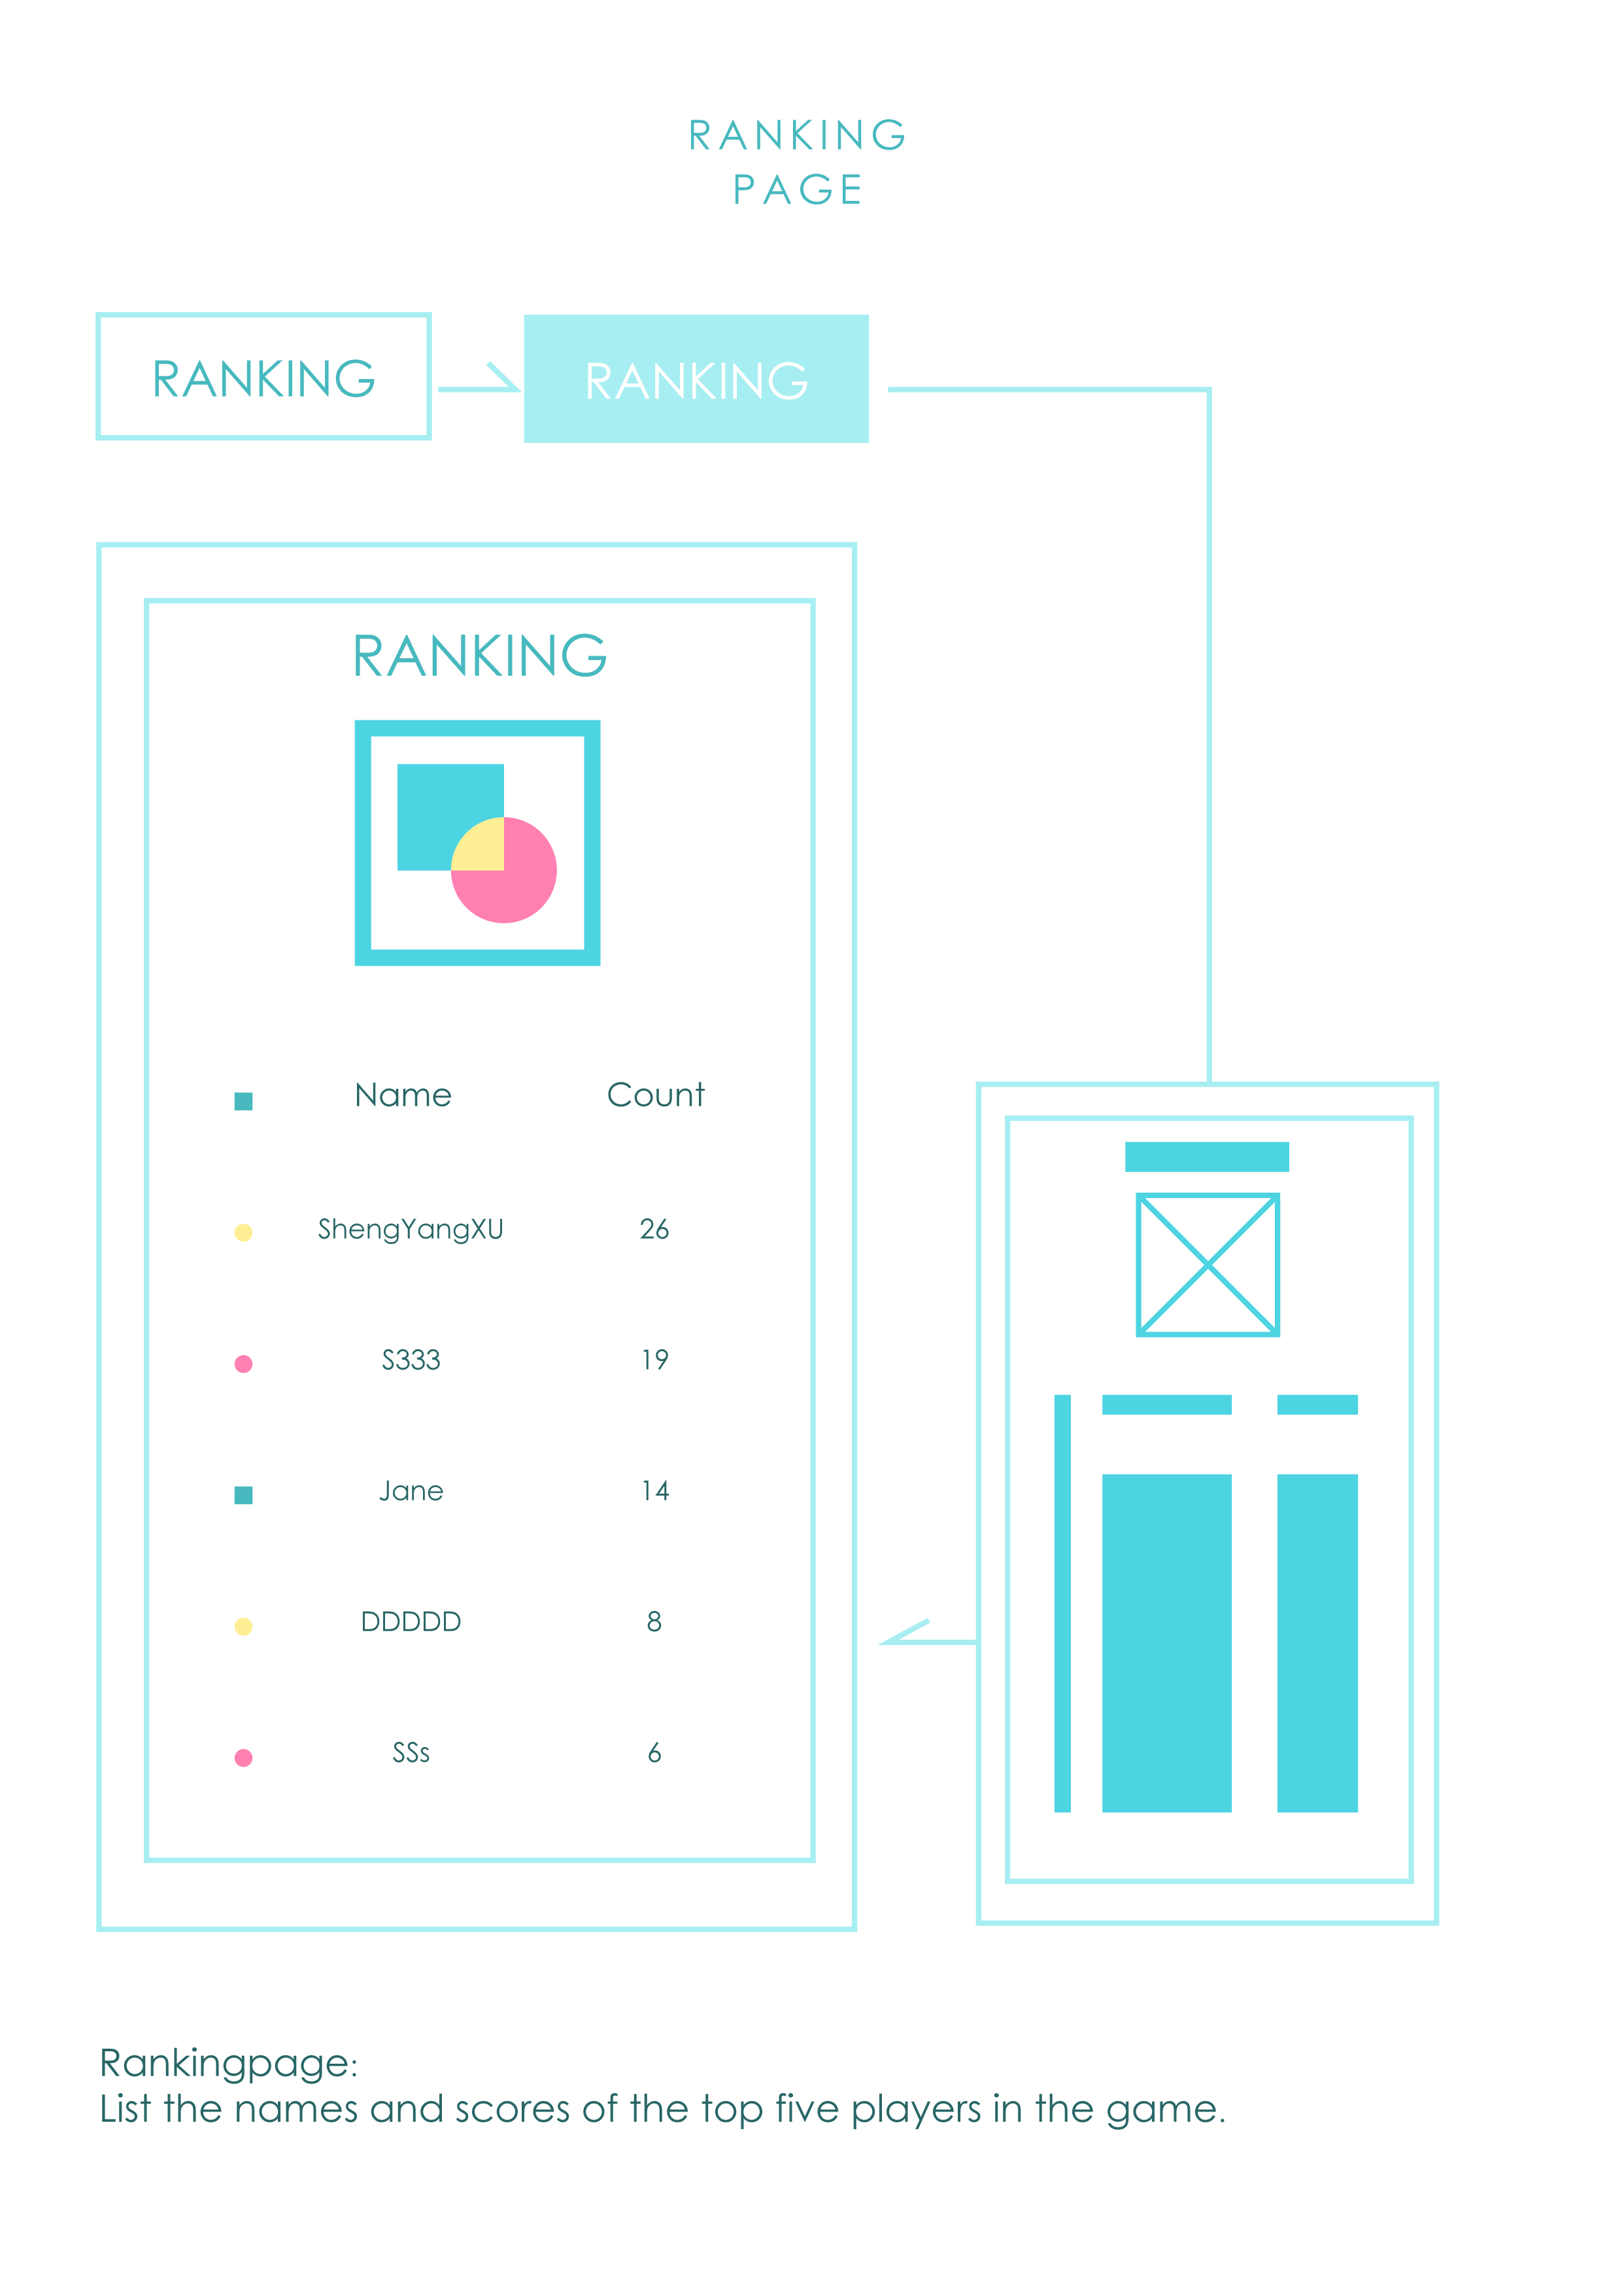

**2. Ranking page:** After clicking the ranking button, the top five records will appear. Three elements of the game are used on the left: blue square, yellow circle and pink circle to divide the ranking.

The names and scores are arranged horizontally, while the top five names and scores are arranged vertically, which makes different names and scores look more orderly.

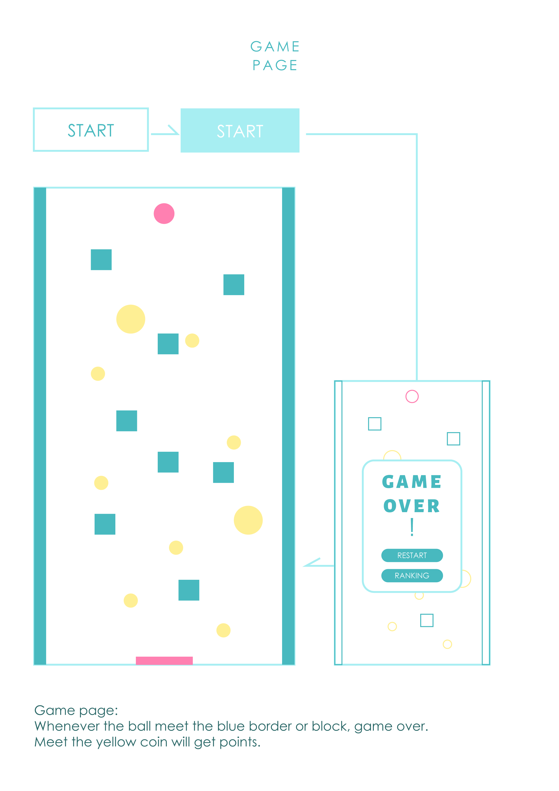

**3. Game page:** After clicking the "start" button, player will enter the main interface of the game. The pink ball will fall from the top. Player needs to touch the pink rectangle at the bottom of the screen to pass the customs. In the process, the ball needs to avoid the blue box that will make the end of the game, and touch as many yellow circles as possible. When you touch the blue box in the middle of the screen or the long rectangle on both sides of the screen, the "game over" box will pop up on the interface to display the current score, restart the game or view the ranking.

Task3: Layout the welcome screen with XML

**ETA**: 1hrs, **Actual**: 1hrs

According to the design of the page at that time, I designed my own layout and interface in XML.

Task4:Define and code functions in welcome screen

**ETA**: 30mins, **Actual**: 1hrs

Because my partner had some problems in setting up the full screen, I spent a certain amount of time to modify it, so it took longer than expected, and then quickly completed the jump to the game interface of the welcome page.

**Release version 1.0**

In this version, we initialize the project, including file, icon, logo, name, etc. Then we designed and arranged the welcome screen, game interface, and ranking interface, but we have a hunch that the design of the interface in the later stage will be modified and improved according to the problems we encounter. For example, when we was on Task 2, I defined obstacles and targets in the game interface in Taks6.

Task5(amend): Redesign & Code the screen of gameActivity—J

**ETA:**2hrs

Task6(amend)::Define functions in game screen— X

**ETA:**30mins

**Release** **version2.0**

**xxx**